|  |  |
| --- | --- |
| cetlogo ***CHEMICAL ENGINEERING TRANSACTIONS***  ***VOL. 86, 2021*** | A publication of  aidiclogo_grande |
| The Italian Association  of Chemical Engineering  Online at www.cetjournal.it |
| Guest Editors: Sauro Pierucci, Jiří Jaromír Klemeš  Copyright © 2021, AIDIC Servizi S.r.l. **ISBN** 978-88-95608-84-6; **ISSN** 2283-9216 | |

Microbial Pb(II) precipitation: the role of biosorption as a Pb(II) removal mechanism

Brandon van Veenhuyzena, Evans M.N. Chirwaa, Hendrik G. Brinka,\*

aDepartment of Chemical Engineering, Faculty of Engineering, Built Environment and Information Technology, University of

Pretoria, Pretoria, South Africa

deon.brink@up.ac.za

The role of a metabolically independent lead removal mechanism in an industrially obtained lead-precipitating consortium was investigated. Cultures were prepared under anaerobic conditions for 24 hours in batch reactors starting with 20 g L-1 tryptone, 10 g L-1 yeast extract, 1.0 g L-1 NaCl and 0.43 g L-1 NaNO3. Bacteria were suspended in 50 mM of sodium azide (NaN3) solution for 3 h to successfully inhibit the microbial respiratory chain, thereby preventing bacteria growth and activity. Fourier-transform infrared spectroscopy (FTIR) was used to inspect whether NaN3 deformed the structure of bacteria cell walls and changed material characteristics.

Reactors containing 100 mL of 80 mg L-1 Pb(II) and 1.0 g/L NaCl were spiked with 1 mL of NaN3-sterilized bacteria culture and sampled over a 3 h period. Bulk Pb(II) concentration and metabolic activity were measured.

Results showed that NaN3 was an effective means to cease metabolic activity of the consortium without altering the surface properties. Pb(II) is still removed from solution (61.7 %) by dead bacteria after NaN3 sterilization, indicating that the initial removal of Pb(II) from solution by the lead-precipitating consortium is an abiotic process. FTIR analysis revealed functional groups such as carboxyl, amine, and phosphate playing a role in Pb(II) biosorption.

Conclusions drawn from this study allow for future experimentation, modelling, and optimization of the biosorption mechanism in an industrially obtained lead-precipitating consortium.

* 1. Introduction

Modern industrial activities, such as mining and battery manufacturing, continue to introduce lead pollutants into the environment. Lead is highly toxic and has been found to accumulate through different trophic levels of ecosystems (Naik et al., 2013)⁠. It serves no biological purpose, but rather harms organisms directly by damaging cell structure or indirectly by impairing enzymes and substituting cationic nutrients.

Most conventional approaches to addressing lead pollution involve immobilizing Pb(II) ions from waste water streams or converting it to a less harmful state, but require additional processing to confront the recovery of Pb(0). These include adsorption, membrane filtration, electrodialysis, ion exchange, chemical precipitation, and electrochemical treatment. Most of these techniques are favourable due to high selectivity, but are burdened with high operating costs and prove uneconomical for treating waste water with low concentrations of Pb(II) (Fu and Wang, 2011). Bioremediation, on the other hand, has proven to be an attractive alternative treatment method due to low operating cost and high remediation efficiency (Kang et al., 2015).

A microbial consortium sourced from lead contaminated soil at a battery recycling plant in South Africa has been shown to remove 90 % of Pb(II) from an 80 mg L-1 solution over a period of 7 days (Brink et al., 2017). It was shown that ionic lead in solution was precipitated out as PbS and elemental Pb by the microbes.

Various Pb-resistance strategies are present in micro-organisms, including intracellular bioaccumulation, extracellular sequestration, surface biosorption, bioprecipitation, cell morphology alteration and metal-ligand complex formation (Naik et al., 2013). SEM analyses on the battery recycling plant consortium indicated that surface Pb(II) bioprecipitation was the dominant lead removal mechanism (Hörstmann et al., 2020).

This study serves to investigate whether biosorption is responsible for an initial phase of Pb(II) removal that acts as a vehicle for concentrating Pb(II) on the surface of the bacteria before bioprecipitation takes place.

The biosorption of heavy metals with bacteria has been widely studied. Several species of bacteria have demonstrated significant Pb(II) biosorption, including *Bacillus firmus* (Salehizadeh and Shojaosadati, 2003), *Micrococcus luteu*s (Puyen et al., 2012), *Pseudomonas putida* (Uslu and Tanyol, 2006), *Pseudomonas aeruginosa* (Chang et al., 1997), and *Streptomyces rimosus* (Selatnia et al., 2004). The chemical composition of bacteria surfaces for both Gram-positive and Gram-negative bacteria are rich in negatively charged functional groups that result in an overall negative surface charge and facilitate the attraction of positively charged metal cations like ionic lead (Vijayaraghavan and Yun, 2008). These functional groups also allow for chemisorption to take place, where hydrogen ions are exchanged for Pb(II) ions (Lu et al., 2012). Chemisorption not only prevents lead from entering cells, but allows for the concentration of lead to be used as a terminal electron acceptor in bioprecipitation (Haas et al., 2001).

* 1. Materials and methods
     1. Material preparation

Cultures were prepared in sterile batch reactors from 0.2 mL of battery recycling plant consortium frozen at - 60 °C. The 100 mL growth suspension contained 20 g L-1 tryptone, 10 g L-1 yeast extract, and 1.0 g L-1 NaCl (Hörstmann et al., 2020). 41 mg L-1 NaNO3 was added to ensure nitrates were present equivalent to the concentration provided by 80 mg L-1 Pb(NO3)2. Batch reactors were purged with nitrogen for 3 min to ensure anaerobic conditions (Peens et al., 2018) and left to grow in a shaker-incubator for 24 h, 35 °C and 120 rpm. To successfully inhibit the microbial respiratory chain and ensure Pb(II) removal through biosorption alone, the culture was exposed to 50 mM of NaN3 (Cabrol et al., 2017) for 3 h after the 24 h growth period.

* + 1. Metabolic activity measurement

Metabolic activity was measured with 3-(4,5-dimethylthiazol-2-yl)-2,5-diphenyl tetrazolium bromide (MTT). MTT is a yellow dye which is reduced to formazan crystals by the dehydrogenase system of viable gram-negative bacterial cells. MTT solution was prepared using 5 g L-1 MTT in ultrapure water. For metabolic activity readings, filtered (0.45 µm) and unfiltered samples were diluted 4 times and mixed with MTT to form a 10% MTT solution. The solution was incubated for an hour, after which formazan crystals were dissolved by dimethyl sulfoxide. Light absorption measurements at 550 nm were performed to infer metabolic activity differences between filtered and unfiltered samples (Peens, 2018).

* + 1. FTIR analysis

Fourier transform infrared (FTIR) spectra of the consortium were measured after three consecutive processes. The first measurement was recorded after a 24 h growth period. The second measurement was recorded following 3 h sterilization of the consortium with 50 mM NaN3. Finally, the third measurement was taken after exposure of the sterilized consortium to 200 mg L-1 Pb(NO3)2. Spectra were recorded on a Perkin Elmer Spectrum 2000GX FTIR spectrometer using an attenuated total reflection (ATR) attachment. All FTIR spectra were recorded at a resolution of 2 cm-1 for 30 scans from 4000 to 550 cm-1 and represent the average of 30 scans.

* + 1. Lead removal experiments

Sterilized reactors containing 100 mL of ultrapure water with 1.0 g L-1 NaCl were prepared. The reactors were spiked with NaN3-sterilized bacteria and various concentrations of Pb(II).

The removal of Pb(II) over a 3 h period was investigated by spiking triplicate reactors containing 80 mg L-1 Pb(II) with 1.0 mL of bacteria. Reactors were sampled at various time intervals and filtered (0.45 µm).

The effect of initial Pb(II) concentration and bacteria concentration on Pb(II) removal was determined by setting up reactors with 1.0 g L-1 NaCl, 50 – 400 mg L-1 Pb(II), and 1.2 – 3.4 mL of bacteria culture. The dry mass of bacteria per mL of culture was determined by centrifuging the culture at 9000 rpm for 10 minutes at 4 °C, rinsing with distilled water, and centrifuging again before being oven dried at 50 °C for 24 h.

The Pb(II) concentration in samples was determined by atomic absorption spectroscopy (Perkin Elmer AAnalyst 400, Waltham, Massachusetts).

* 1. Results
     1. FTIR analysis

The presence of functional groups was confirmed by FTIR analysis. In Figure 1, the broad peak found around 3298 cm-1 was attributed to O-H stretching (Francioso et al., 2010), whereas the band at 1640 cm-1 was assigned to the presence of -C=O in amide I (Y. Liu et al., 2016). The addition of NaN3 appears to do little to affect the surface properties of the consortium. This is seen in Figure 1a) and Figure 1b). A difference between the two spectra is observed at 2040 cm-1 in Figure 1b), with this band signaling the presence of N≡N from NaN3 (Tao et al., 2011). The addition of Pb(II) results in a significant disruption in transmittance between 1550 and 900 cm-1, as observed in Figure 1c). The appearance of new peaks could be indicative of the cell wall rupturing, resulting in the exposure of various functional groups from the inside the cell. This consortium has been recorded growing in Pb(II) concentrations around 1000 mg L-1 (Peens et al., 2018), making such destructive effects of 200 mg L-1 Pb(II) on cell walls unlikely.

Alternatively, the appearance and strengthening of weak bands could show chemisorption of Pb(II) to particular surface functional groups. Bands are described as appearing if they were not discernable in the spectra of NaN3-sterilized cultures but became apparent in Figure 1c).

The appearance of a band at 1537 cm-1 may be indicative of interference or deformation of N-H bending in amide II, and is suggestive of Pb(II) binding (Masoumi et al., 2016). The strengthening of the band at 1451 cm-1 and subsequent shift to 1454 cm-1 could signal Pb(II) interactions with CH3 and CH2 groups of lipids and proteins (Z. Liu et al., 2016). The strengthening and shift of the band at 1406 cm-1 to 1393 cm-1 is likely a result of COO- groups (Dittrich and Sibler, 2005) binding with Pb(II). Additionally, the strengthening and shift of the 1240 cm-1 band to 1235 cm-1 could arise from lead binding with P=O functional groups of phosphorylated proteins or polyphosphate storage products (Dittrich and Sibler, 2005). The appearance of a band at 1030 cm-1 may be attributed to a variety of mixed modes of carbohydrates (Z. Liu et al., 2016) or carboxyl groups (Lu et al., 2012). Finally, the appearance of a band at 956 cm-1 is likely due to Pb(II) interfering with C=C bending in alkenes.

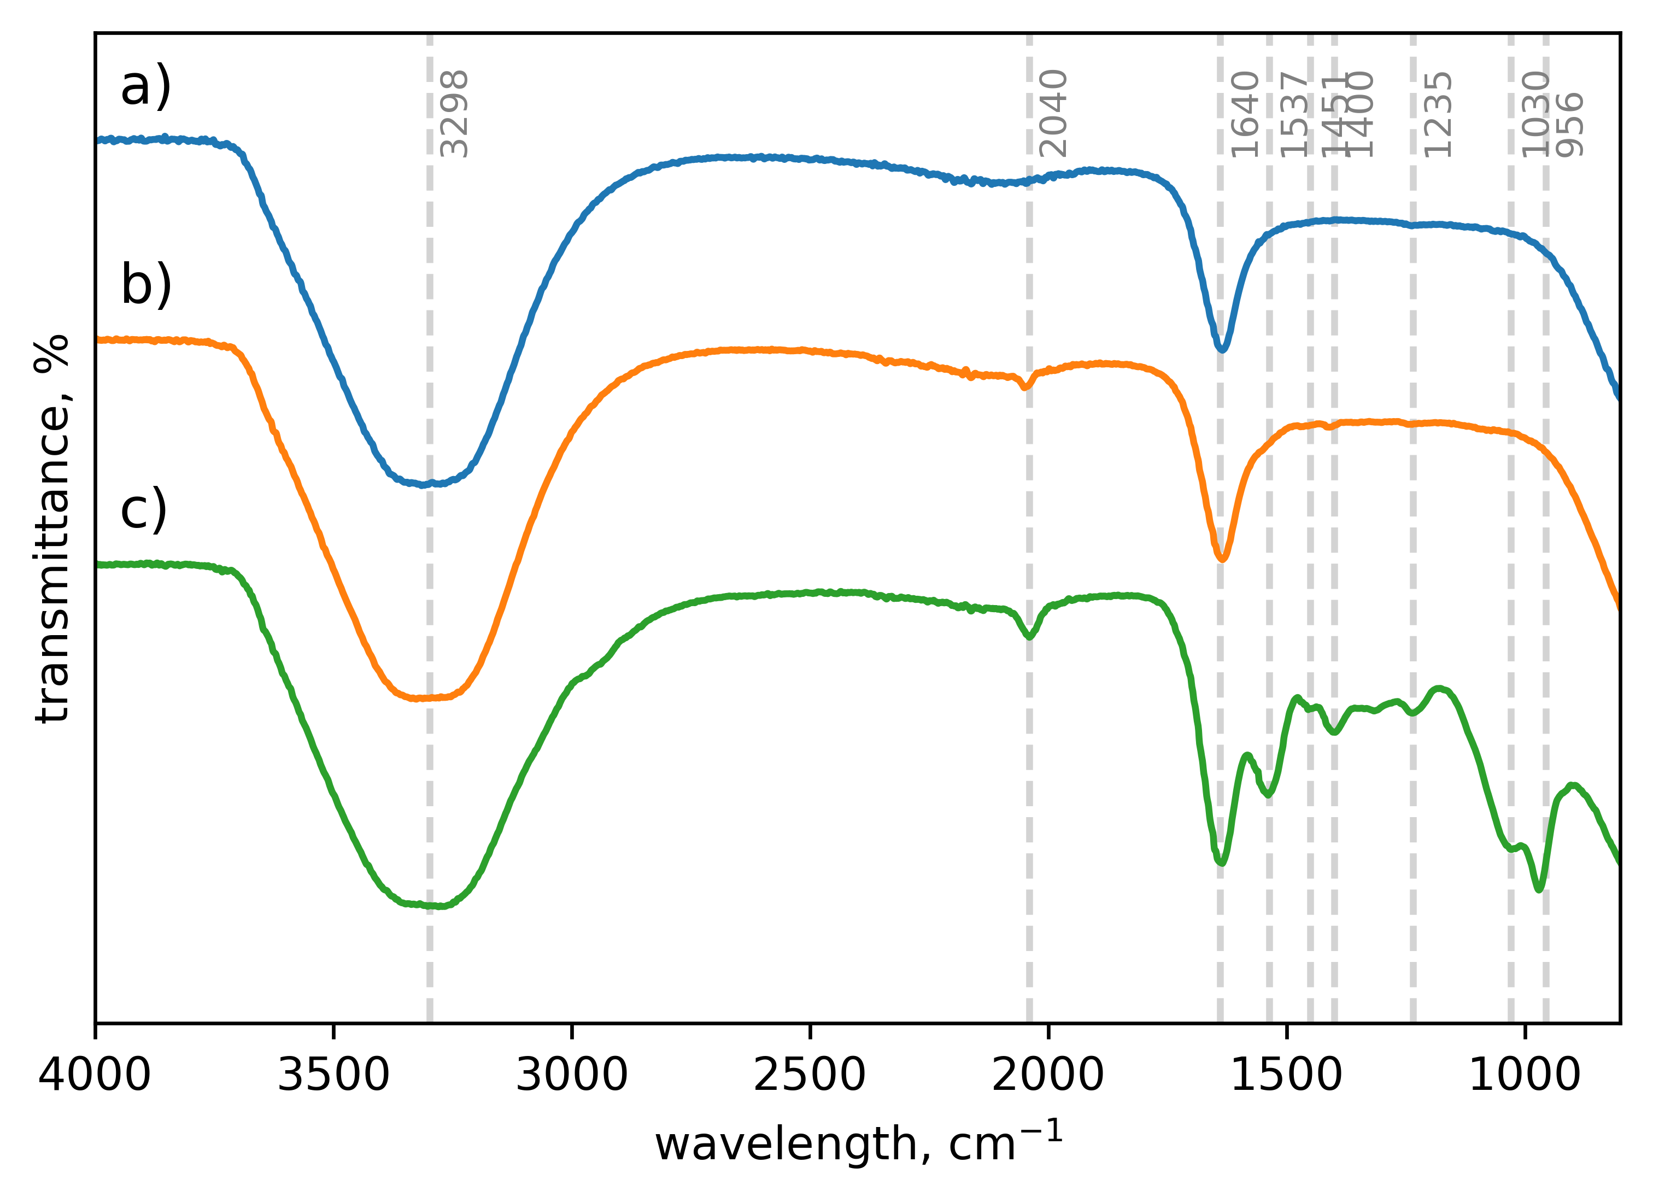

Figure 1: FTIR spectra of bacteria consortium a) after 24 h growth period, b) after 3 h exposure to NaN3, and c) after exposure to NaN3 and Pb(NO3)2.

These findings are consistent with literature reports of functional groups involved in the chemisorption of heavy metals to biomass, including carboxyl groups (Fomina and Gadd, 2014), amine (Fein et al., 1997), phosphate (Ngwenya et al., 2003), and carbonyl (Mathew and Krishnamurthy, 2018).

* + 1. Lead removal experiments

Following 3 h, 61.7 ± 4.86 % of Pb(II) was removed from solution by NaN3-sterilized bacteria (Figure 2).

In addition, no metabolic activity was detected in any of the reactors using MTT. This indicates that a passive mechanism was involved in lead removal. The concentrations used were also found to be within the solubility range of Pb(N3)2 (Lieber et al., 1966), confirming that lead removal was caused by the presence of the battery recycling plant consortium alone. No black/grey precipitate was discernable following a 24 h period, signaling a lack of PbS or Pb(0) formation.

As shown in Figure **3**, an increase in bacteria mass dosing was found to produce a clear increase in Pb(II) removal. This is presumably due to an increase in available sorption sites. An increase in initial Pb(II) concentration from 0 mg L-1 to 100 mg L-1 shows greater Pb(II) removal, most likely due to a stronger concentration gradient. A similar effect was seen with Pb(II) adsorption onto carbon nanofibers (Ahmed et al., 2010). Above 150 mg L-1 a decrease in adsorption is observed with increases in initial Pb(II) concentration, indicating the limitation of adsorption sites being reached at these concentrations. As seen in Table 1, lead removal by the battery recycling plant consortium requires significantly less biomass when compared to several previous studies.

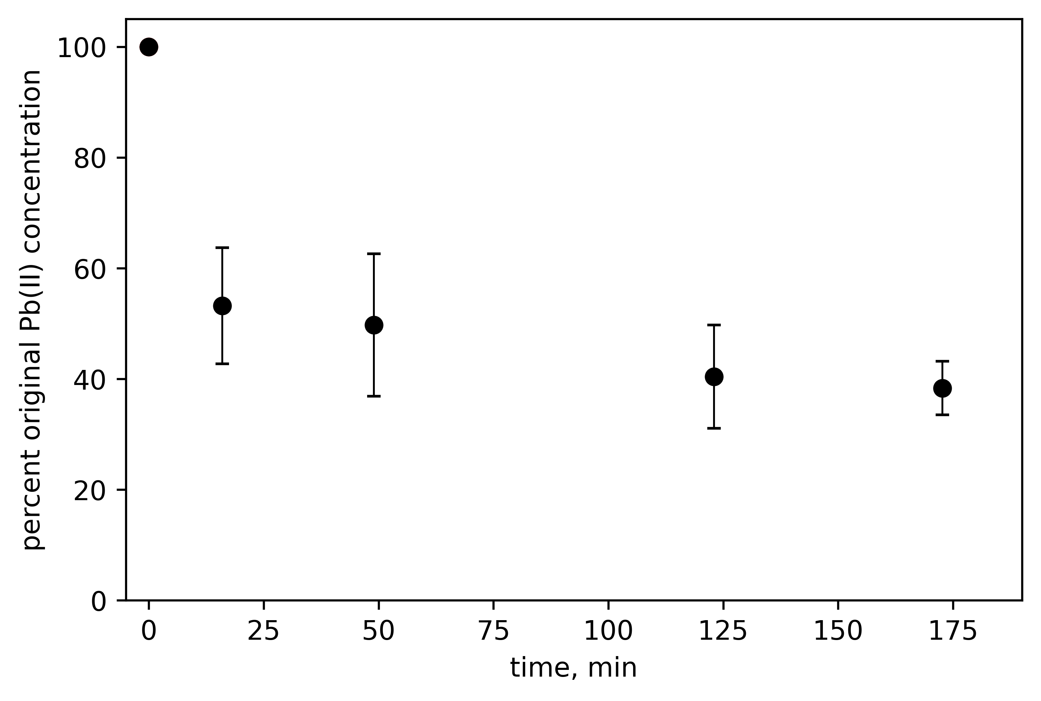These results suggest that biosorption is responsible for the initial, rapid removal of Pb(II) from solution. Since both biosorption and precipitation of Pb(II) occur on the surface, it is likely that the biosorption of lead ions onto bacteria cell walls is a necessary precursor to the precipitation of Pb(II) to PbS or Pb(0). More intensive biosorption investigations should be done to enable a detailed biosorption model that can be incorporated into models of microbial Pb(II) precipitation.

*Figure 2: Percent lead remaining in solution as a function of time after the addition of the NaN3-sterilized consortium.*

*Table 1: Comparison of lead removal by various bacteria.*

|  |  |  |  |  |  |
| --- | --- | --- | --- | --- | --- |
| Bacteria | Mass (mg) | Original Pb(II) concentration (mg L-1) | Time (h) | Percent removal | Source |
| *Acinetobacter junii* L. Pb1 | 606 | 100 | 6 | 74 | Kushwaha et al (2017) |
| *Bacillus sp*. (ATS-1) | 2000 | 100 | 0.25 | 74 | Tunali et al. (2006) |
| Battery recycling plant consortium | - | 80 | 3 | 50 | Hörstmann et al. (2020) |
| Battery recycling plant consortium | 47.5 | 150 | 3 | 63 | This study |
| *Rhodococcus sp. HX-2* | 750 | 200 | 0.5 | 47 | Hu et al., (2020) |
| *Streptomyces rimosus* | 3000 | 500 | 3 | 20 | (Selatnia et al., 2004) |

Conclusions

Sodium azide successfully inhibited metabolic activity of the consortium without damaging the cell walls of bacteria, allowing for Pb(II) removal through abiotic mechanisms to be studied. It was found that 61.7 ± 4.86 % of Pb(II) is removed in 3 h by non-living bacteria. FTIR spectroscopy supported the chemisorption of lead onto functional groups as being responsible for this removal. The amount of consortium dosed and the initial Pb(II) concentrations used were found to have a non-linear effect on lead removal, with Pb(II) concentration gradient being a limiting factor at concentrations less than 150 mg L-1 whereas binding sites become the limiting factor above 150 mg L-1. These results pave the way for future studies to do more detailed abiotic lead removal experimentation.

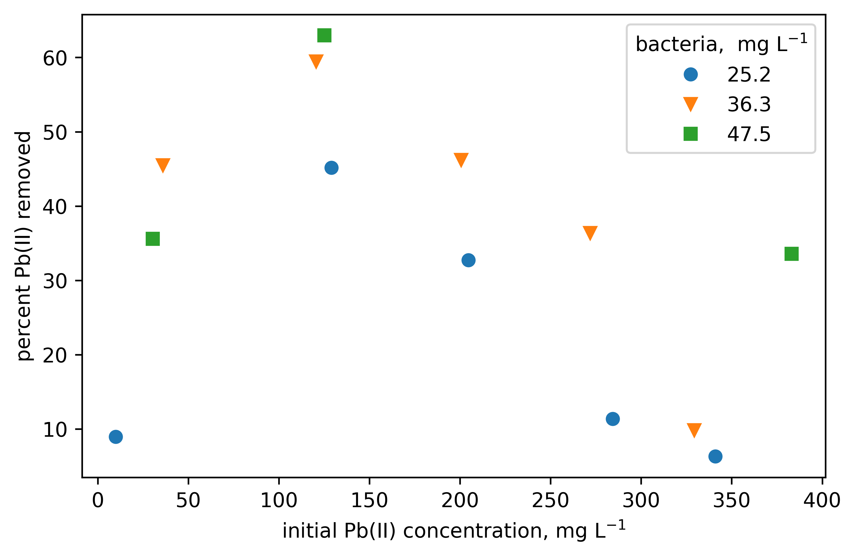

*Figure 3: The effects of NaN3-sterilized bacteria concentration and initial Pb(II) concentration on lead removal. The concentration of bacteria is given as a dry mass.*

Acknowledgments

This work is based on the research supported in part by the National Research Foundation of South Africa (Grant Numbers 106938 and 123022).

References

Ahmed, Y.M., Mamun, A. Al, Muyibi, S.A., Al-Khatib, M.F.R., Jameel, A.T., AlSaadi, M.A., 2010. Effect of Adsorbate Initial Concentration on the Removal of Pb from Aqueous Solutions by Carbon Nanofibers, in: 24th Symposium of Malaysian Chemical Engineers (SOMChE 2010) and 1st International Conference on Process Engineering and Advanced Materials 2010 (ICPEAM2010). Kuala Lumpur, pp. 15–17.

Brink, H.G., Lategan, M., Naudé, K., Chirwa, E.M.N., 2017. Int. Conf. Energy, Environ. Clim.

Cabrol, L., Quéméneur, M., Misson, B., 2017. J. Microbiol. Methods 133, 62–65.

Chang, J.S., Law, R., Chang, C.C., 1997. Water Res. 31, 1651–1658.

Dittrich, M., Sibler, S., 2005. J. Colloid Interface Sci. 286, 487–495.

Fein, J.B., Daughney, C.J., Yee, N., Davis, T.A., 1997. Geochim. Cosmochim. Acta 61, 3319–3328.

Fomina, M., Gadd, G.M., 2014. Bioresour. Technol. 160, 3–14.

Francioso, O., Rodriguez-Estrada, M.T., Montecchio, D., Salomoni, C., Caputo, A., Palenzona, D., 2010. J. Hazard. Mater. 175, 740–746.

Fu, F., Wang, Q., 2011. J. Environ. Manage. 92, 407–418.

Haas, J.R., Dichristina, T.J., Wade, R., 2001. Chem. Geol. 180, 33–54.

Hörstmann, C., Brink, H.G., Chirwa, E.M.N., 2020. Sustainabilty.

Hu, X., Cao, J., Yang, H., Li, D., Qiao, Y., Zhao, J., Zhang, Z., Huang, L., 2020. PLoS One 15.

Kang, C.H., Oh, S.J., Shin, Y.J., Han, S.H., Nam, I.H., So, J.S., 2015. Ecol. Eng. 74, 402–407.

Kushwaha, A., Rani, R., Kumar, S., Thomas, T., David, A.A., Ahmed, M., 2017. Environ. Sci. Pollut. Res. 24, 10652–10661.

Lieber, E., Rao, C.N.R., Dingle, H.E., Teetsov, J., 1966. J. Chem. Eng. Data 11, 105.

Liu, Y., Alessi, D.S., Owttrim, G.W., Kenney, J.P.L., Zhou, Q., Lalonde, S. V., Konhauser, K.O., 2016. Geochim. Cosmochim. Acta 187, 179–194.

Liu, Z., Huang, Y., Zhao, G., 2016. BioResources 11, 3178–3190.

Lu, H., Zhang, W., Yang, Y., Huang, X., Wang, S., Qiu, R., 2012. Water Res. 46, 854–862.

Masoumi, F., Khadivinia, E., Alidoust, L., Mansourinejad, Z., Shahryari, S., Safaei, M., Mousavi, A., Salmanian, A.H., Zahiri, H.S., Vali, H., Noghabi, K.A., 2016. J. Environ. Chem. Eng. 4, 950–957.

Mathew, B.B., Krishnamurthy, N.B., 2018. Groundw. Sustain. Dev. 7, 313–327.

Naik, M.M., Khanolkar, D., Dubey, S.K., 2013. Ecotoxicol. Environ. Saf. 98, 1–7.

Ngwenya, B.T., Sutherland, I.W., Kennedy, L., 2003. Appl. Geochemistry 18, 527–538.

Peens, J., 2018. Pb (II)-Removal From Water Using Microorganisms Naturally Evolved to Tolerate Pb(II)-Toxicity. University of Pretoria, Pretoria.

Peens, J., Wu, W.Y., Brink, H.G., 2018. Chem. Eng. Trans. 64, 439–444.

Puyen, Z.M., Villagrasa, E., Maldonado, J., Diestra, E., Esteve, I., Solé, A., 2012. Bioresour. Technol. 126, 233–237.

Salehizadeh, H., Shojaosadati, S.A., 2003. Water Res. 37, 4231–4235.

Selatnia, A., Boukazoula, A., Kechid, N., Bakhti, M.Z., Chergui, A., Kerchich, Y., 2004. Biochem. Eng. J. 19, 127–135.

Tao, P., Li, Y., Rungta, A., Viswanath, A., Gao, J., Benicewicz, B.C., Siegel, R.W., Schadler, L.S., 2011. J. Mater. Chem. 21, 18623–18629.

Tunali, S., Çabuk, A., Akar, T., 2006. Chem. Eng. J. 115, 203–211.

Uslu, G., Tanyol, M., 2006. J. Hazard. Mater. 135, 87–93.

Vijayaraghavan, K., Yun, Y.S., 2008. Biotechnol. Adv. 26, 266–291.